**Name:** Hewan Teklu

**Class:** IT 520-A – Enterprise Infrastructure & Networks

**Date:**10/22/18

**Lab 5 – Traceroute**

1. What is your computers IP address? (This is not included in your traceroute results). Take a screenshot of your computers IP address.

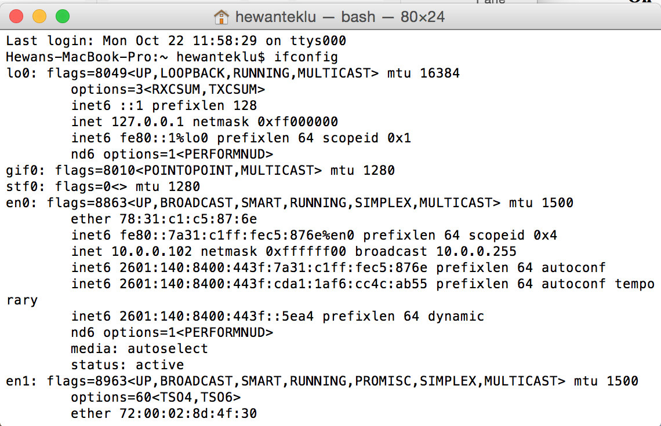

**Solution:**

**My IP address according terminal is 10.0.0.102**

1. With reference to private/public IP addresses. What type of IP address is the first IP from your traceroute result.

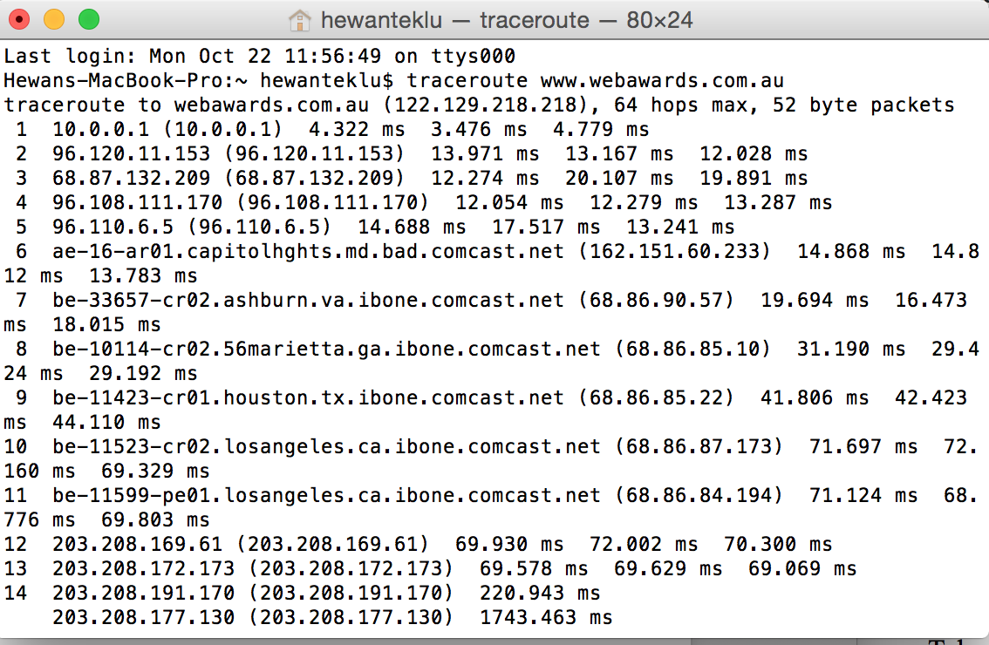

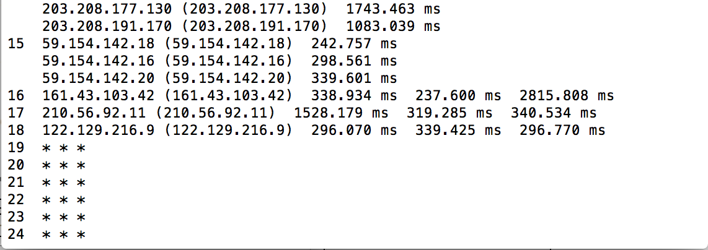

**Solution:**

**With reference to private/public IP addresses, the first IP from my traceroute result 10.0.0.1 is a Private IP address**

1. With reference to private/public IP addresses. What type of IP address is the second IP from your traceroute result.

**Solution:**

**With reference to private/public IP addresses, the Second IP from my traceroute result 96.120.11.153 is a Public IP address.**

1. In a tabular format (use table example below), and in sequential order. Indicate the location of each IP address (include state for US states) and the organization that owns the IP address. (Use https://www.ultratools.com/tools/ipWhoisLookup to look up IP address whois information).

|  |  |  |  |
| --- | --- | --- | --- |
| Hop Count | IP Address | Organization (IP Owner) | Location (US state)/Country |
| 1 | 10.0.0.1 | Internet Assigned Number Authority (IANA) | Los Angeles, CA/US |
| 2 | 96.120.11.153 | Comcast IP Services, L.L.C | Mt Laurel, NJ/US |
| 3 | 68.87.132.209 | Comcast Cable Communications, Inc. | Mt Laurel, NJ/US |
| 4 | 96.108.111.170 | Comcast Cable Communications, Inc. | Mt Laurel, NJ/US |
| 5 | 96.110.6.5 | Comcast Cable Communications, Inc. | Mt Laurel, NJ/US |
| 6 | 162.151.60.233 | Comcast Cable Communications, Inc. (CCCS) | Mt Laurel, NJ/US |
| 7 | 68.86.90.57 | Comcast Cable Communications, Inc. | Mt Laurel, NJ/US |
| 8 | 68.86.85.10 | Comcast Cable Communications, Inc. | Mt Laurel, NJ/US |
| 9 | 68.86.85.22 | Comcast Cable Communications, Inc. | Mt Laurel, NJ/US |
| 10 | 68.86.87.173 | Comcast Cable Communications, Inc. | Mt Laurel, NJ/US |
| 11 | 68.86.84.194 | Comcast Cable Communications, Inc. | Mt Laurel, NJ/US |
| 12 | 203.208.169.61 | Singapore Telecommunications (SINGTEL Internet Exchange) | Singapore/SG |
| 13 | 203.208.172.173 | Singapore Telecommunications Pte Ltd | Singapore/SG |
| 14 | 203.208.191.170 | Singapore Telecommunications (SINGTEL Internet Exchange) | Singapore/SG |
|  | 203.208.177.130 | Singapore Telecommunications (SINGTEL Internet Exchange) | Singapore/SG |
|  | 203.208.191.170 | Singapore Telecommunications (SINGTEL Internet Exchange) | Singapore/SG |
| 15 | 59.154.142.18 | ORG-SOPL2-AP | Australia/AU |
|  | 59.154.142.16 | ORG-SOPL2-AP | Australia/AU |
|  | 59.154.142.20 | ORG-SOPL2-AP | Australia/AU |
| 16 | 161.43.103.42 | ORG-SOPL2-AP | AU |
| 17 | 210.56.92.11 | IPWAN, MPLS & ADSL broadband technologies | AU |
| 18 | 122.129.216.9 | ORG-WPPL1-AP | AU |
|  | | | |

1. In your own words, explain everything you just did, and what route did your packet took from source to destination. How many US states did your packet go through? How many countries if any?

**Solution:**

I used Terminal since I am a Mac user. On Terminal, I typed traceroute and the website name given for this assignment (www.webawards.com.au) in effort to diagnose the packet routes across the IP network. During the packet delivery process, total of eighteen (18) IP addresses were used from the source to the destination. The packet went through only two (2) US States, which were Los Angeles, CA and Mt Laurel, NJ (from Los Angeles, CA/US to Mt Laurel, NJ/US). Then the packet went outside the US, to be specific, to two (2) countries namely Singapore and Australia (from Singapore to Australia). Then the packet reached its destination IP address.